Solution to Question 1 : Installed Power BI and Shared the final screenshot of the Reports View Page which appears when the Power Desktop starts.

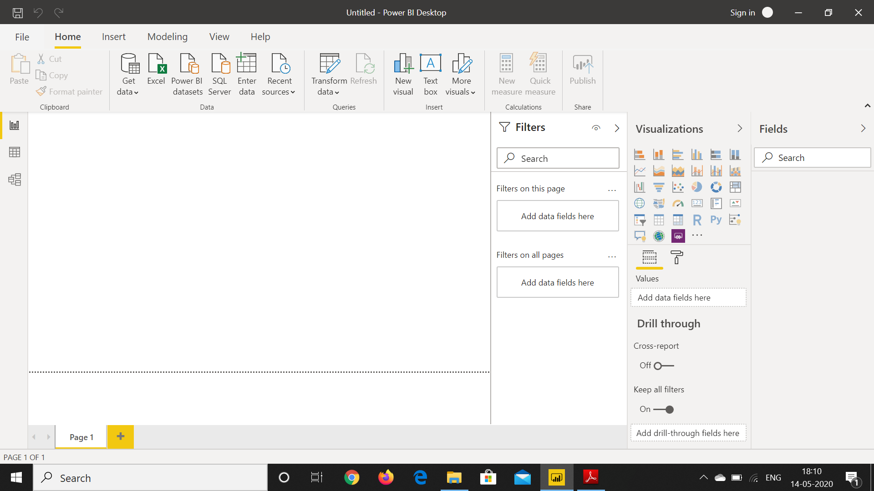

Question 2 Please find all the requisite screenshots below:

1)Connecting to a PDF document:

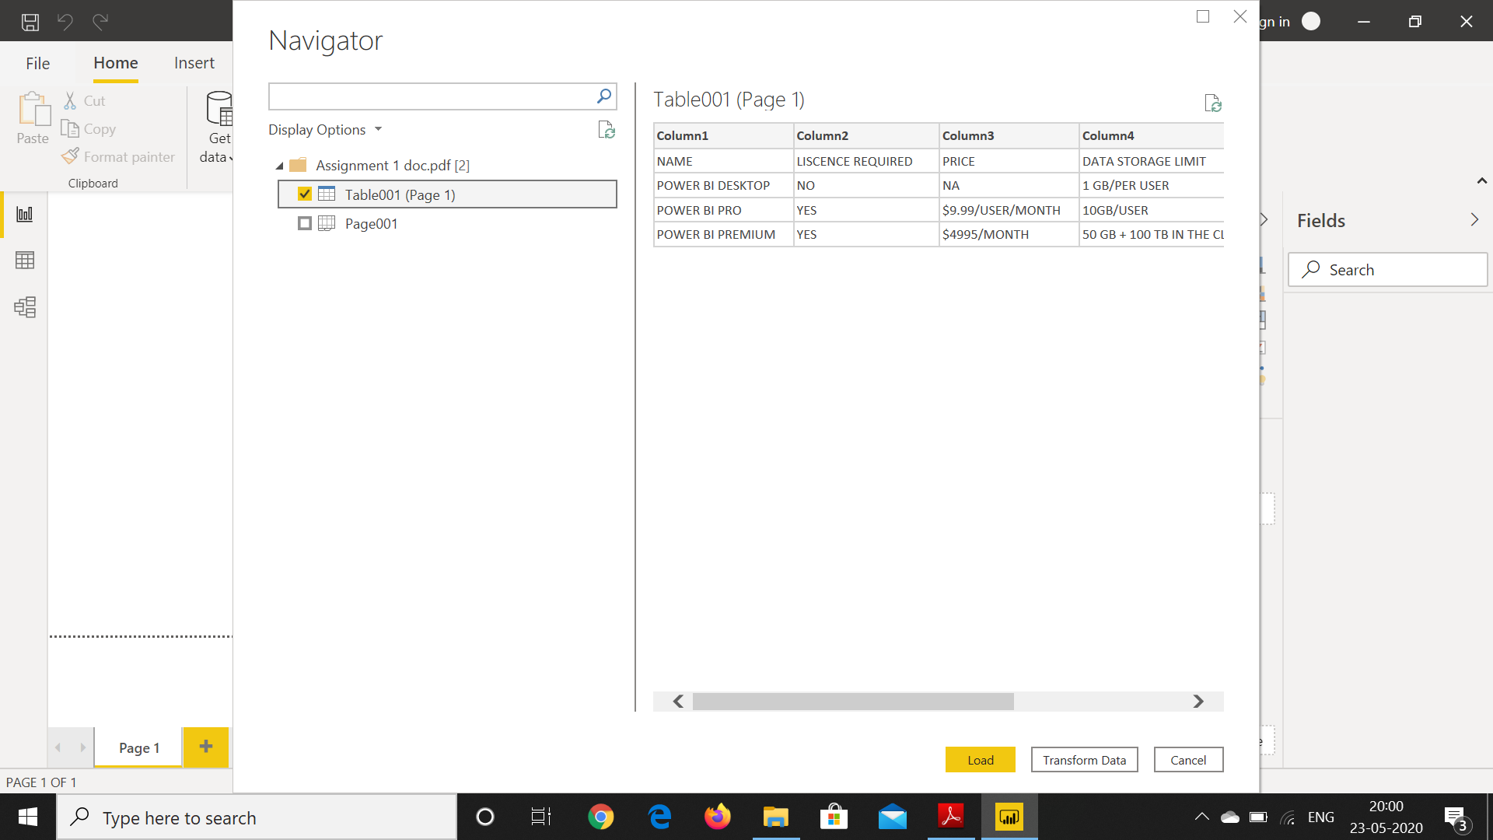

2) Power Query Editor

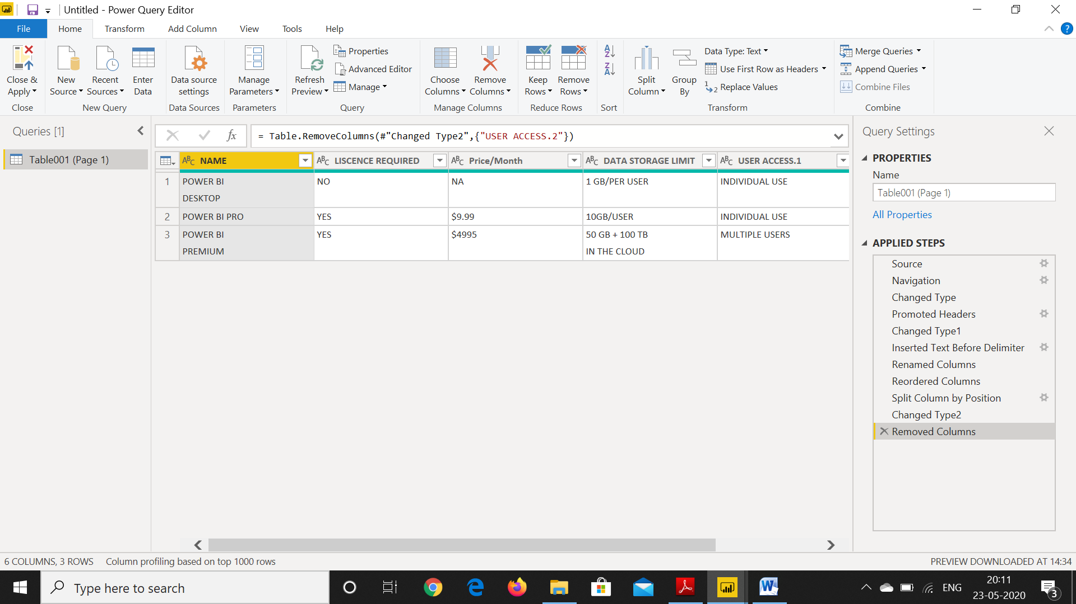

3) Advanced Editor

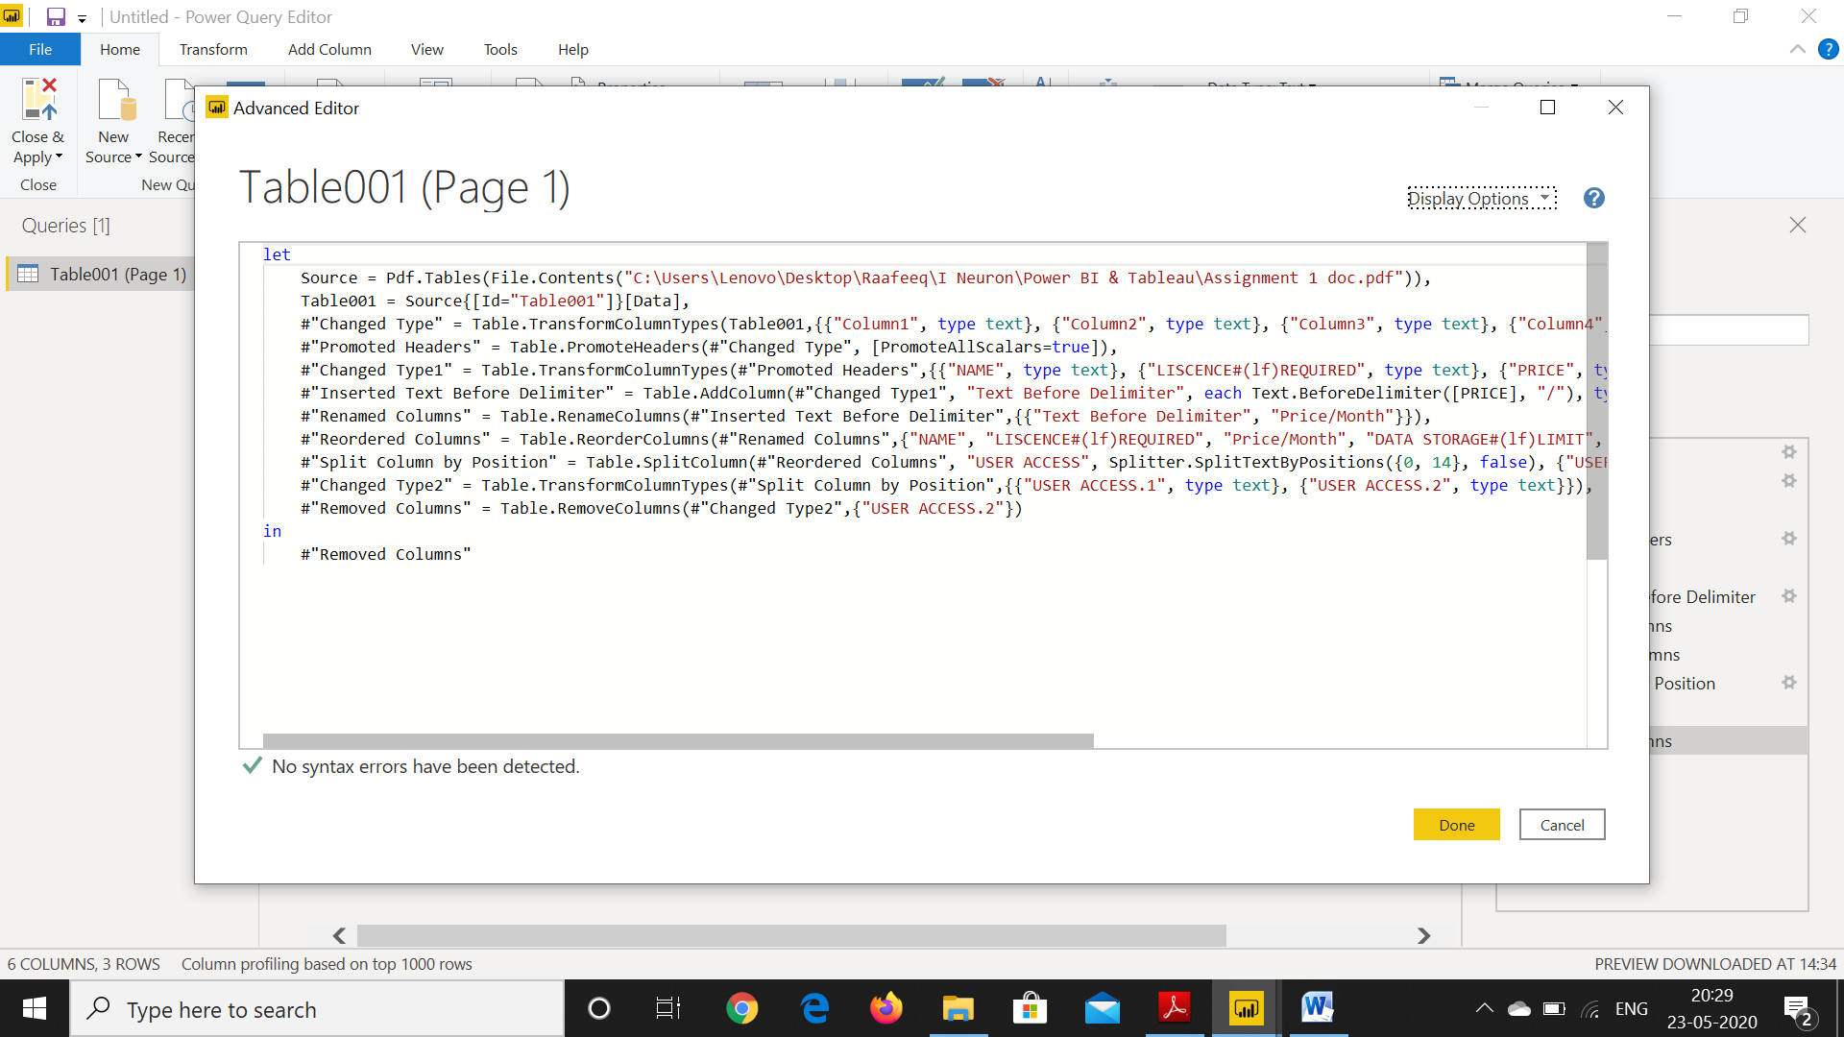

4) Model View

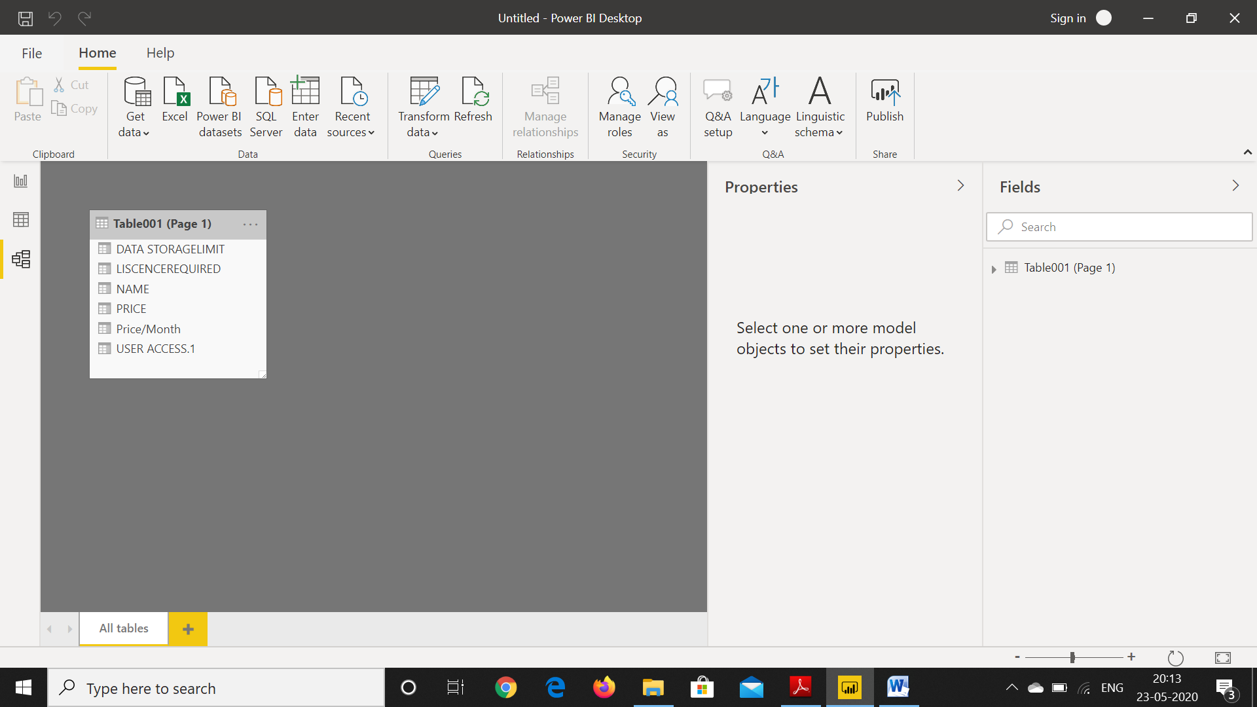

5) Data View

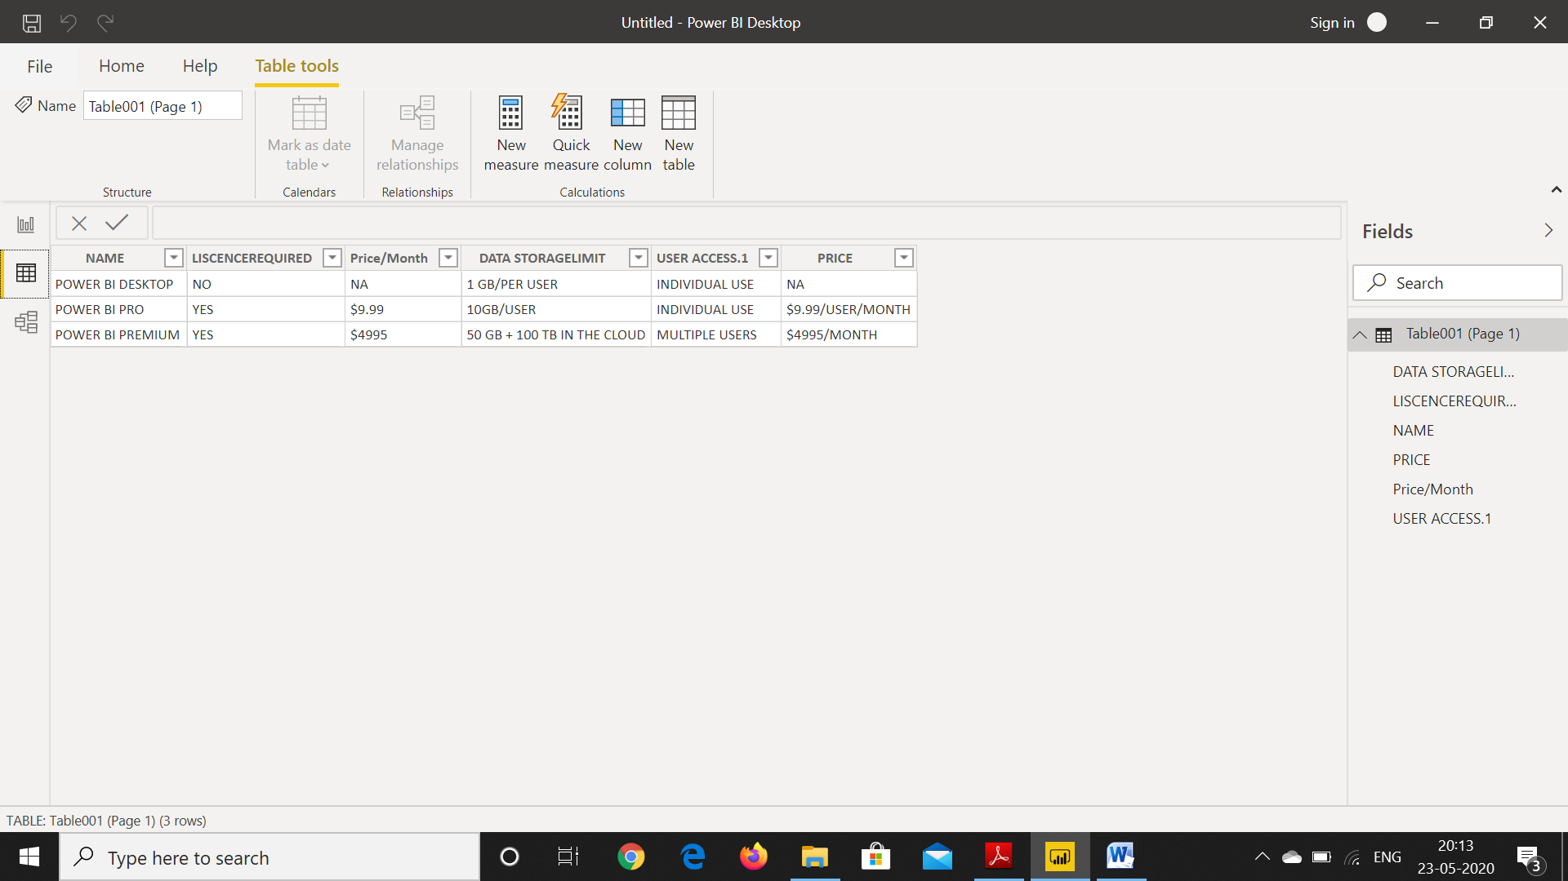

6) Report View

